BEng Software Engineering

SWE6204 – Machine Learning

Data Set Project and Report

Contents
1.1 Supervised, Unsupervised, and Reinforcement Learning 3
Supervised Learning 3
Unsupervised Learning 4
Reinforcement Learning 5
1.2 Decision Trees 6
How Decision Trees Work 6
Advantages and Disadvantages 7
1.3 Hierarchical Clustering vs. K-Means Clustering 8
Hierarchical Clustering 8
K-Means Clustering 9
Hierarchical Clustering in Real Life 9
Differences Between Hierarchical Clustering and K-Means Clustering 9
1.4 Social and ethical issues in the application of machine learning 10
1.5 Overfitting 12
Methods to Prevent Overfitting 12
Cross-Validation 12
Regularization 12
Dropout 12
Early Stopping 13
Pruning 13
1.6 Classification Evaluation Metrics 13
Evaluation Metrics 14
Accuracy 14
Precision 14
Recall 14
F1 Score 15
Task 2 15
Machine Learning 15
Dataset Overview 16
2.1 Importing Libraries and loading data set 16
Problem Statement 16
2.2 Exploratory Data Analysis 19
2.3 Split the Dataset into Train and Test 24
2.4 Machine Learning Algorithms and Building the Model 25
2.5 Evaluate the performance of the model 27
Confusion Matrix: 27
Equations: 27
2.6 Feature importance and distribution of prediction probabilities 29
2.7 Interpreting the Model 30
Conclusion 31
References 31

1.1 Supervised, Unsupervised, and Reinforcement Learning
One of the major branches of artificial intelligence dealing with the automatic discovery of the patterns present in data and the building of models that make predictions or decisions without the application of explicit programming of algorithms is called machine learning. The three major paradigms on which this field is categorized so far are supervised, unsupervised, and reinforcement learning.

Supervised Learning
Supervised learning is thus the learning of a model on a set of labeled input-output pairs. "The agent learns from some example input-output pairs and learns a function mapping from input to output," Russell and Norvig (2021, p. 695).

With supervised learning, one does the learning with labelled data, meaning the input comes with a realization of the desired output. Examples of implementations commonly used and studied in supervised learning include artificial neural network architectures, decision tree inductions, and linear regressions.
Examples include:
• The house price predictor estimates the prices of residential houses from multiple input features such as location, dimensional parameters, and structural attributes, based on historical transactional data.
• Email spam filtering involves training of emails classified as either "spam" or "not spam" to filter new emails.
• Image recognition is classifying objects in new images based on training with labeled images.
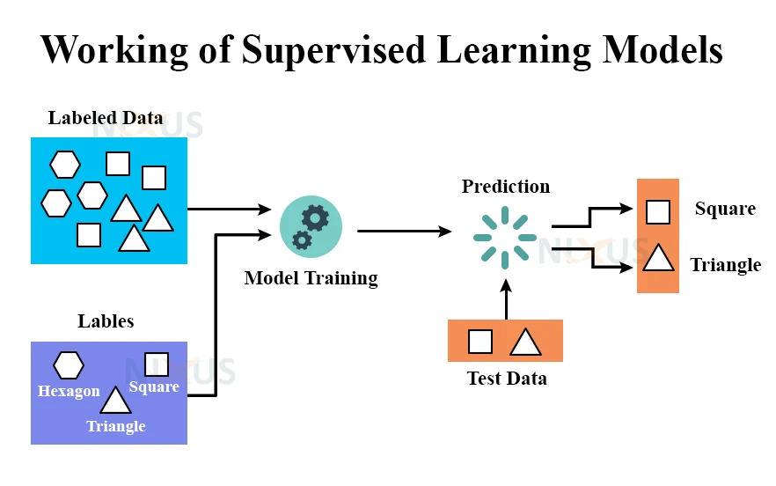
Figure of Supervised Learning (Team, 2022)

Unsupervised Learning
Conversely, in unsupervised learning, the training of algorithms is carried out on datasets without any explicit labels or pre-defined output variables. This is most typically used either for clustering similar data into pre-defined categories or for discovering patterns and trends in raw datasets. "In supervised learning, we can always use cross validation to select between non-probabilistic models of different complexity, but this is not the case with unsupervised learning." (Murphy, 2012, p. 372).

Examples:
- Customer segmentation: Partitioning of customer populations by transactional data and behavioral patterns into homogeneous subsets with no predetermined segment labels.
- Anomaly detection: Detection of statistically anomalous data points in transactional data sets, for example, credit card purchases, possibly indicating fraudulent activity without having seen any previous examples of such anomalies.
- Topic modeling: Inference of abstract topics from a collection of documents.
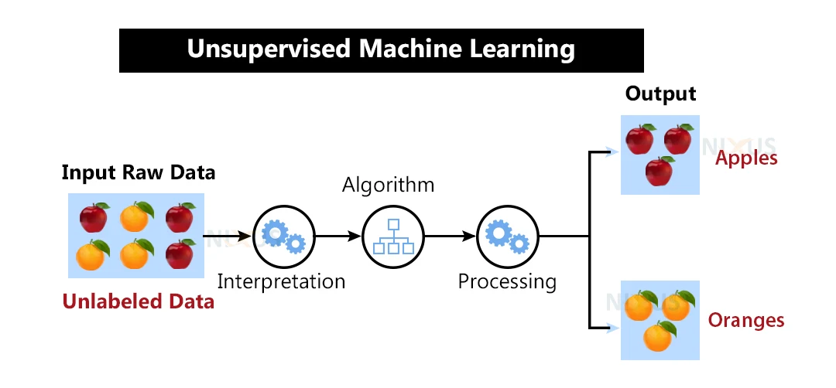
Figure of Unsupervised Learning (Team, 2022)

Reinforcement Learning
Reinforcement learning is a way of making an agent interact with an environment in order to maximize reward-gathering behavior. "Reinforcement learning problems involve learning what to do how to map situations to actions so as to maximize a numerical reward signal."(Sutton & Barto, 2018, p.2).
Examples include:
• Robotic Arm: Robotic actuators learn reward-based approach to perform difficult tasks of manipulation like grasp and move objects.
• Autonomously drive: Learning by trial and error to drive.
• Resource management: Using reinforcement learning techniques draw down funds for optimal functioning of complex systems like data centers.

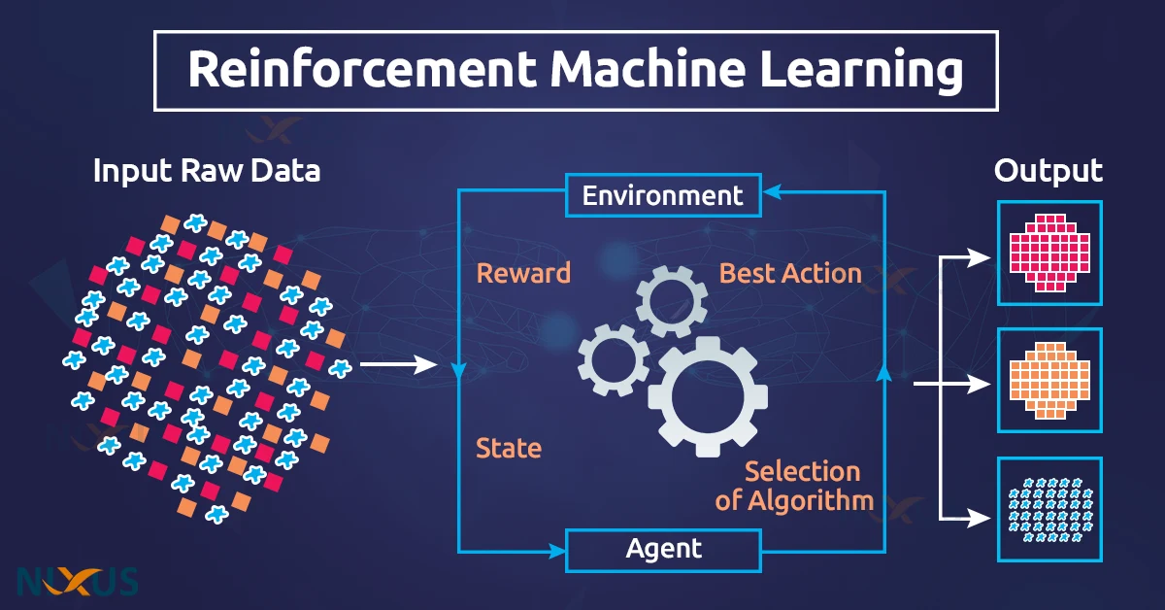
Figure of Reinforcement Learning (DFNT, 2022)

1.2 Decision Trees
The idea behind decision trees is to use recursive partitioning to break up the feature space in a tree-like structure that is top-down rather than bottom-up, supported by a flowchart. Broken down structurally, a decision tree comprises internal nodes that represent decision points, branches that represent outcomes, and leaf nodes that represent final classifications. This construct of algorithms aims to create a particular model for prediction, where the target-variable's value is derived from understandable decision rules based on acquiring the input feature set. Decision trees can be used for both classification or regression and are, therefore, a flexible means of predictive modeling.

How Decision Trees Work
The construction of the decision tree begins with selecting the feature that best partitions the dataset. After this, the algorithm makes repeats of the classification of the current dataset into mutually exclusive subsets according to the values of the selected feature.
The repeated partitioning continues until all data points fall into homogeneous leaf nodes or one of the assigned stop criteria, such as minimum sample size or maximum depth of a tree, is reached.
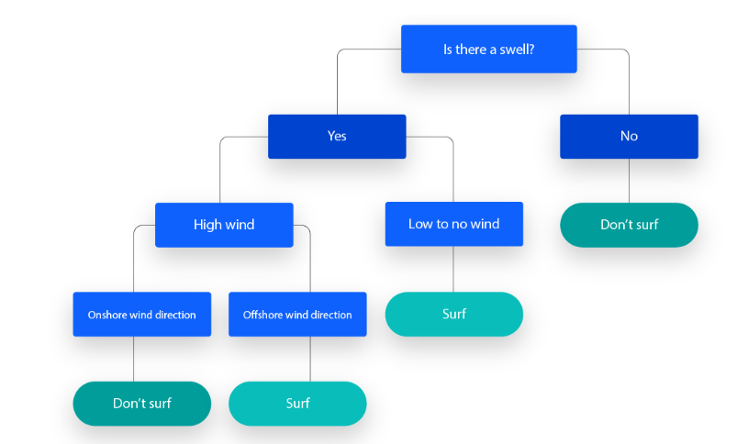
Figure of Decision Tree (IBM, 2021)

Advantages and Disadvantages
Advantages:
- Interpretability: They are easy to explain and interpret because they follow the human thinking process.
- No preprocessing of data is required: The trees can handle both numeric and categorical data without normalization.
- Non-parametric: They do not assume anything about the distribution of the data.
- Missing value treatment: They are able to work with data that may have missing values by using surrogate splits.
- Automatic feature selection: The algorithm selects the most significant features.

Disadvantages:
1. Overfitting: They are often prone to forming too complex trees, ones that do not generalize well on unseen data.
2. Instability: With small variance, drastic modification in data can result in huge alteration in the tree structure.
3. Biases for classes: Trees are biased when the class distributions are highly unbalanced.
4. They are not the best in the business: They are often outperformed by algorithms such as random forests or gradient boosting regarding accuracy.
5. Diagonal decision boundaries are unrealized: Relationships not aligned with the axes of the features struggle against them.

1.3 Hierarchical Clustering vs. K-Means Clustering

Hierarchical Clustering
"Hierarchical clustering algorithms are either top-down or bottom-up. Bottom-up algorithms treat each document as a singleton cluster at the outset and then successively merge (or agglomerate) pairs of clusters until all clusters have been merged into a single cluster that contains all documents." (Manning et al., 2008, p. 378).
Unlike partitioning methods that require prior fix in the number of clusters, hierarchical clustering determines the cluster-relatedness autonomously. Hence, this makes it most suitable in exploratory data analysis with visualization of the structure lying beneath the data especially in small data sets.

K-Means Clustering
"Unlike K-means and EM, most hierarchical clustering algorithms do not have a probabilistic interpretation." (Manning et al., 2008, p. 400). It assigns a data member to one of the K clusters while lower intra-cluster variance does not necessarily mean one iteration. K is the number of desired clusters and modes of partition (centroid) based.
Each data point is assigned to the cluster whose centroid, which serves as the geometric center of the cluster, is closest in distance. This method is appreciated for its performance on large data sets.

Hierarchical Clustering in Real Life
It serves as a method of grouping species in biological taxonomy in this sense-by genomic similarities. The organization begins from the analysis of a single species, and then gradually, the algorithm combines more closely related species into clusters which become larger groups that eventually lead to that hierarchical structure representing the phylogenetic tree of all life. This way, evolutionary biology can show how different taxa, genus, family, order, and so on have evolved without specifying beforehand how many such taxonomic group categories there will be.

Differences Between Hierarchical Clustering and K-Means Clustering
Aspect | Hierarchical Clustering | K-Means Clustering
Approach | Builds a tree of clusters (dendrogram) | Partitions data into k distinct clusters
Number of Clusters | Does not require predefined number of clusters | Requires number of clusters (k) to be specified beforehand
Algorithm Type | Can be agglomerative (bottom-up) or divisive (top-down) | Iterative partitioning
Visualization | Provides a dendrogram showing the hierarchy of clusters | No hierarchical representation
Sensitivity to Outliers | Less sensitive to outliers | Highly sensitive to outliers
Deterministic | Results are deterministic (same input always gives same output) | Results depend on initial centroid placement
Memory Requirements | Requires storage of distance matrix (high memory usage) | Lower memory requirements

1.4 Social and ethical issues in the application of machine learning
The ethical and social concerns surrounding machine learning have great significance. These issues must all be addressed in order to implement this technology responsibly.
1. Bias and Discrimination
The functionality of the machine-learning system can be biased by inherent bias present in the data used for training purposes. The consequence of such discrimination in this history includes wrongful hiring practices and denial of loans, and ML models find precedent in furtherance of discrimination thereby amplifying.
"It has recently been shown that algorithms trained with biased data have resulted in algorithmic discrimination" (Bolukbasi et al., 2016; Caliskan et al., 2017). For instance, the training data for facial recognition systems is commonly biased, resulting in high error rates for women and darker-skinned people.
2. Privacy and Surveillance
Using ML for facial recognition, predictive analytics, and behavioural tracking, organizations and states can extract and analyse huge amounts of personal data. When consent is absent or lacking regulation, this invariably infringes upon an individual's right to privacy. Implemented in public, these technologies enable mass surveillance that corrosively impacts avenues of trust and personal liberty.
3. Accountability and Transparency
Many machine learning models, either deep learning based or not, do not readily explain their decision processes. These "black box" systems resist a normal audit or explanation of their affordances, and the uses of such systems create a breach in public confidence.
As Rudin (2019) noted: "A fundamental challenge is that many machine learning models operate as black boxes, making it difficult to understand how they arrive at a particular decision or prediction".
4. Job Displacement and Economic Inequality
Increasingly, ML and automation systems are used in occupational settings so they will replace some jobs. While it might increase efficiency, it may at the same time threaten workers without the requisite skills to transition to new jobs.
Frey and Osborne (2017) estimate that "approximately 47% of total US employment is at risk of computerization".

1.5 Overfitting
Overfitting occurs when a machine learning model learns the training set data very well, in terms of learning the noise and random variations rather than the actual underlying patterns.

Methods to Prevent Overfitting

Cross-Validation
Cross-validation is the splitting of dataset into small subsets, train the model using some of the subsets and validate performance against the other remaining subsets.

Regularization
Regularization adds a penalty term to the loss function to discourage complex models. Common regularization techniques include:
- L1 regularization (Lasso): Adds the sum of absolute values of weights to the loss function, encouraging sparsity.
- L2 regularization (Ridge): Adds the sum of squared weights, preventing any weight from becoming too large.
- Elastic Net: Combines L1 and L2 regularization.

Dropout
Dropout is a form of training specifically in neural networks, in which some chosen neurons are ignored during training, preventing co-adaptation.

Early Stopping
Early stopping is defined by the observation of the performance of the model with respect to a validation set during training. It interrupts further training as soon as this performance starts to decrease, indicating that overfitting is beginning.

Pruning
Pruning is the removing of any part of the decision trees and neural networks that do not give much predictive power in order to reduce complexity.

1.6 Classification Evaluation Metrics
Evaluation metrics support appropriate classification model performance evaluation. These evaluation metrics help you see the model's accuracy and its ability to correctly identify different classes, plus whether it’s making more false positives or false negatives.
Powers (2011) points out that the confusion matrix is the backbone of most classification evaluation metrics, giving you a detailed view of how the model is performing beyond just a simple yes or no. A confusion matrix is simply a table where the actual true and false predictions of models lie side by side.

Evaluation Metrics

Accuracy
It helps assess how well a model performs on average by giving out the proportion of all predictions in which it predicts true results (TP and TN) out of the total.
Accuracy = (TP + TN) / (TP + TN + FP + FN).
Despite its being simple-sounding, accuracy can, at times, be misleading, especially in imbalanced datasets.

Precision
Precision tells us how many positive cases were predicted to be right. This is especially crucial in cases where false positives can create serious problems, such as in medical diagnosis.
Precision = TP / (TP + FP)

Recall
Recall is the number of true positive instances that the model correctly predicts. It is especially important in cases where severe consequences result from not detecting a true positive, for example, fraud detection.
Recall = TP / (TP + FN)

F1 Score
F1 Score refers to how the harmonic mean comes from precision and recall and provides a nice trade-off among both values. It is useful in not having a uniform spread of classes.
F1 Score = 2 x (Precision x Recall) / (Precision + Recall)
Each of these metrics provides different insights into how your model is performing, for instance, specifications regarding a model not being accurate just because accuracy is high. Thus, depending on what you're doing, different metrics might be more appropriate.

Task 2

Machine Learning
Machine learning is a subfield of artificial intelligence that implies the development of algorithms capable of learning from data and making some decisions and predictions without programming (Russell & Norvig, 2020).
Supervised learning is a very popular machine learning approach. It is characterized by training models on labelled data to perform some predictions. This project involves a supervised classification approach aimed at predicting the click behavior from session data of the user, which is a technique widely used to improve recommendations and marketing strategies.

Dataset Overview
The dataset used in this project contains user interaction logs from an e-commerce platform. It consists of session-level data including both user and product-related features, and whether the user clicked on the product.
Column | Description
device_type | Type of device used (e.g., mobile, desktop)
user_id | Unique identifier for the user
session_id | Unique identifier for the session
item_id | Unique identifier for the item/product
item_price | Price of the product
category | Broad classification of the item
product_type | Specific product subtype
impression_time | Timestamp when the product was shown
app_code | Application version or variant
os_version | Operating system version of the device
is_4G | Whether the user was using a 4G network
is_click | Target variable indicating if the item was clicked (1 = Yes, 0 = No)

2.1 Importing Libraries and loading data set

Problem Statement
The main aim of the machine learning project is to train models on historic click data from user session information to predict whether the user will click on a given product listing during a session. We cast this as a classification problem with the target variable being 'is_click'. Higher accurate predictions will help refine product recommendations and target users, leading to an enhanced user experience and increased conversion.
Tools and Libraries
Several Python libraries are essential for handling and analyzing the dataset:
- NumPy: A library for numerical operations and handling arrays (Harris et al., 2020).
- Pandas: Used for data manipulation and analysis. It provides data structures like DataFrame that are perfect for structured data (McKinney, 2010).
- Matplotlib: Basic plotting library mainly used for visualization of data distributions and patterns.
- Seaborn: Built on Matplotlib, this eases and beautifies statistical plotting.
- Scikit-learn (sklearn): An efficient and powerful library that offers a broad range of machine learning algorithms, including clustering, classification, and regression.
Common Functions
- .read_csv(): Reads a dataset from a comma-separated values (CSV) file and loads it into a Pandas DataFrame.
- .read_excel(): Similar to .read_csv() but is used for Excel files.
- .head(): Displays the first 5 rows of the dataset.
- .tail(): Displays the last 5 rows of the dataset.
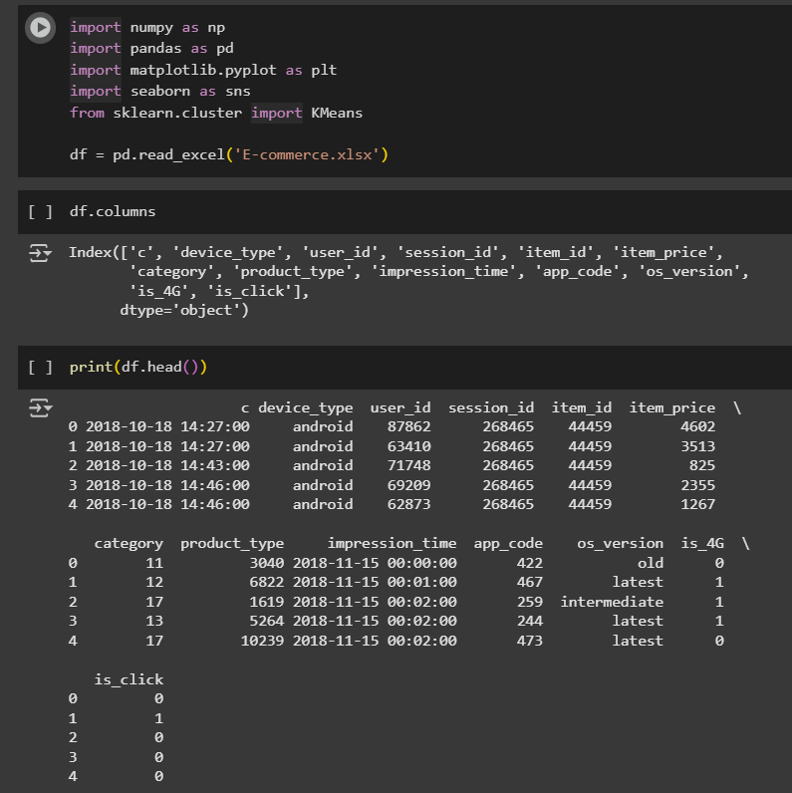

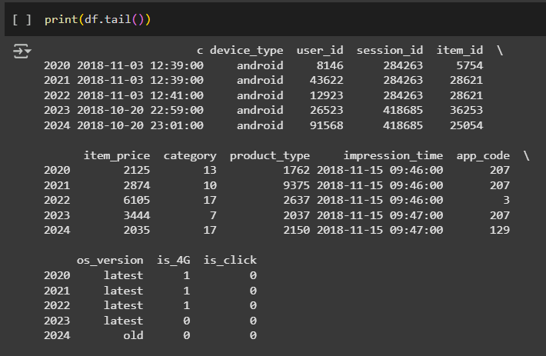

2.2 Exploratory Data Analysis
Exploratory Data Analysis (EDA) is a fundamental step in understanding the underlying structure, patterns, and anomalies in a dataset. It helps identify potential data quality issues, gain insights into feature distributions, and informs the selection of suitable preprocessing and modeling techniques (Tukey, 1977).

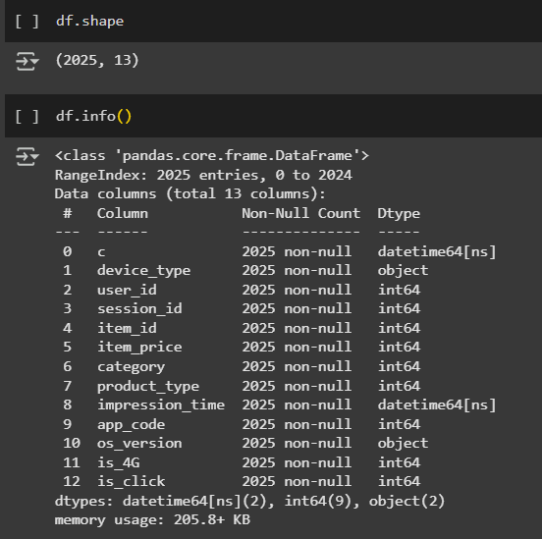
In the screenshot above, we are checking the structure of the loaded dataset.
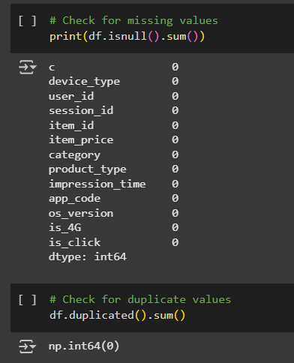
Here, we are checking for missing and duplicated values. The dataset “E-commerce” has no missing or duplicate values.
Methods to deal with null values:
- Drop: If there is a lot of missing data in the column, we can drop the column altogether.
- Impute: Use mean, median, or mode for numerical data, or the most frequent category for categorical data.
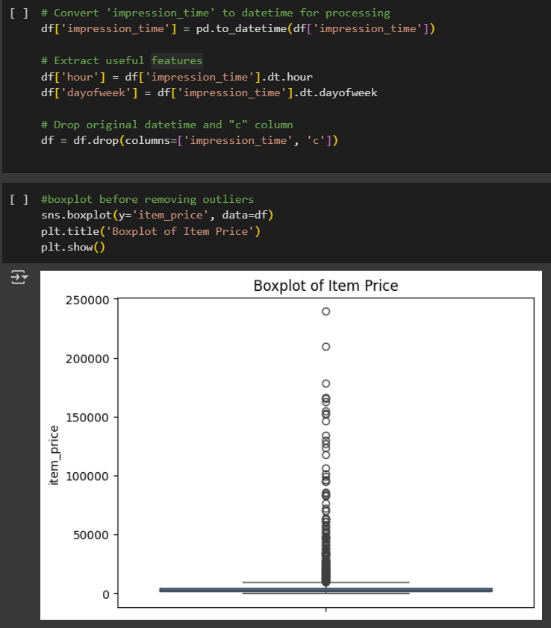
We took “impression_time” and extracted specific components of the date/time, like the hour of the day or day of the week, which are often more useful for modeling than raw timestamp strings. Then, we dropped “c” and “impression_time” since there is no longer any use for it.
A box plot before removing and cleaning the dataset is displayed for item price.
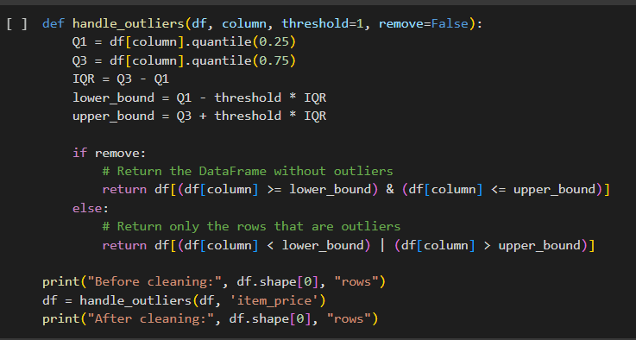
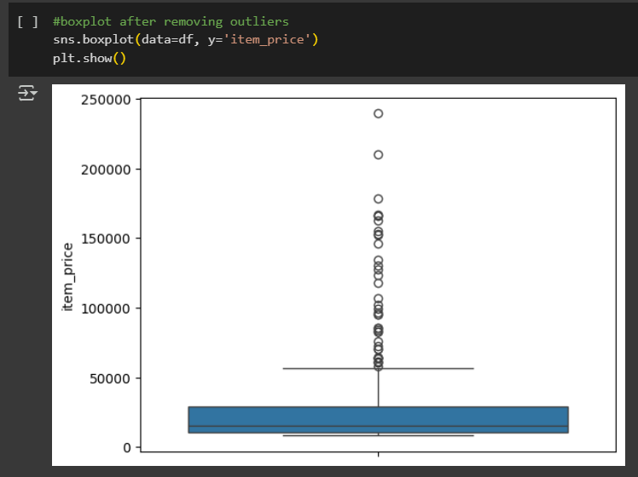
In the screenshot above, we used the Interquartile Range (IQR) method to detect outliers then remove them. A box plot after removing outlier is shown.

2.3 Split the Dataset into Train and Test
Splitting the dataset into training and testing ensures that the model learns patterns in the training set and is evaluated fairly on new, unseen data in the test set. This prevents overfitting and ensures generalizability.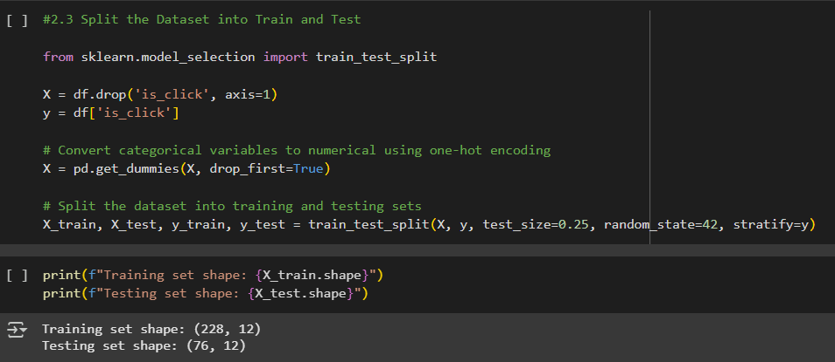
Categorical features (like device_type, category, product_type, etc.) are converted into binary numerical format using one-hot encoding as machine learning algorithms can’t work with strings or categories directly.
We reserved 20% of the dataset for testing. “random_state” at 42 ensures reproducibility. “stratify=y” ensures the distribution of target labels (“is_click”) is consistent across train and test sets. The shape shows that the model is being trained on 228 samples and tested on 76.
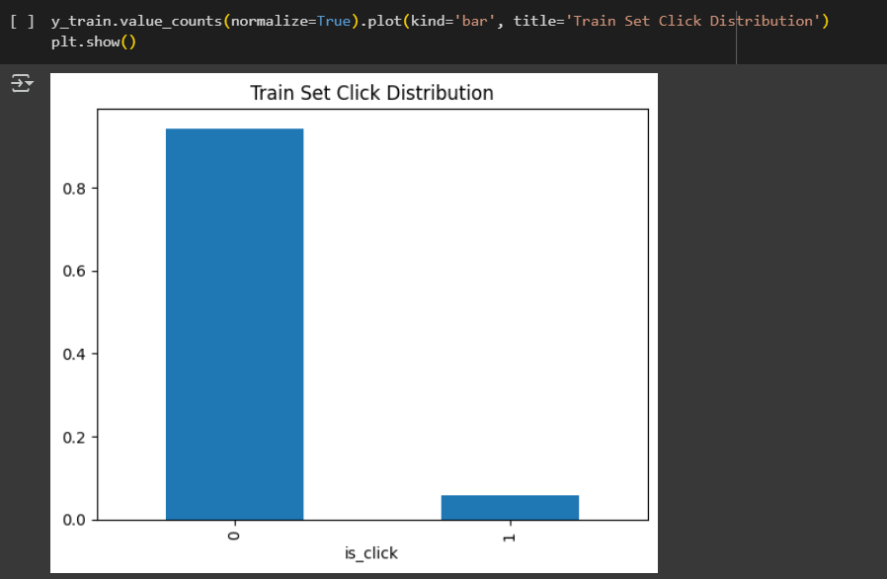
The bar graph visualizes the distribution of click vs no-click in the training set.

2.4 Machine Learning Algorithms and Building the Model
Now, we will apply classification models that predict whether a product will be clicked (is_click) based on features such as device type, category, app code, and others.
We will implement five classification algorithms:
1. Logistic Regression: A primary classifier that presents the likelihood of a binary outcome (James et al., 2013).
2. K-Nearest Neighbor (KNN): Determines the closest training examples in the feature space to classify objects. Clicking patterns can also be revealed using a comparison of similar users or sessions.
3. Decision Tree Classifier: Constructs a model to predict the target value of learning simple decision rules from the features.
4. Random Forest Classifier: Builds numerous classifiers by creating multiple decision trees, outputting the mode of their classifications.
5. Support Vector Machine (SVM): Identify hyperplane, which segregates the data points into distinct classes.

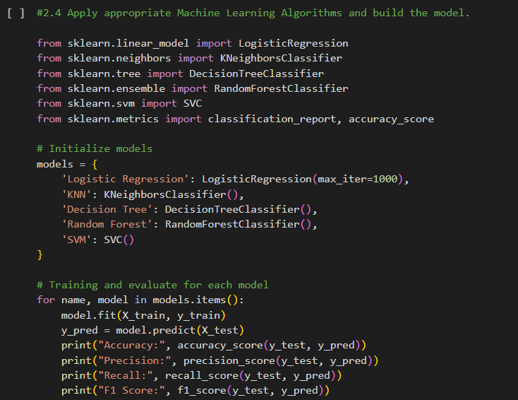
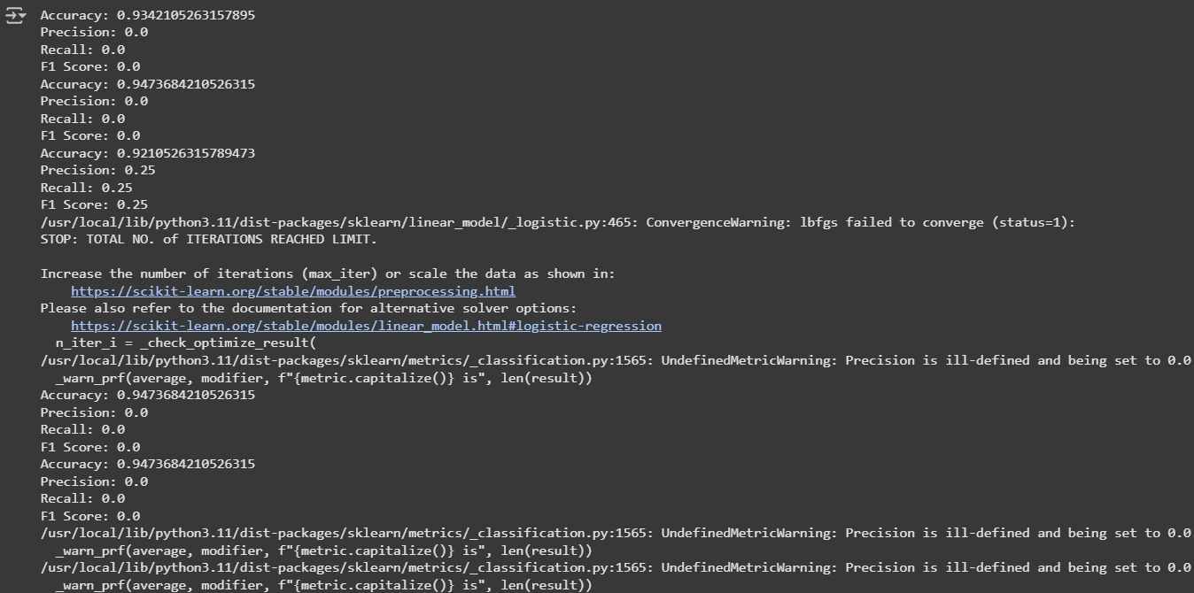
“model.predict(X_test)” estimates clicks while “accuracy_score” and “classification_report” assess model performance using metrics like precision, recall, and F1-score.

2.5 Evaluate the performance of the model

Confusion Matrix:
Confusion matrices are widely used in binary classification to assess the predictive performance of models (Geron, 2019):
- True Positives (TP): Correctly predicted clicks (actual = 1, predicted = 1)
- True Negatives (TN): Correctly predicted no-clicks (actual = 0, predicted = 0)
- False Positives (FP): Incorrectly predicted clicks (actual = 0, predicted = 1)
- False Negatives (FN): Incorrectly predicted no-clicks (actual = 1, predicted = 0)

Equations:
Accuracy = (TP + TN) / (TP + TN + FP + FN)
Precision = TP / (TP + FP)
Recall = TP / (TP + FN)
F1-Score = 2 × (Precision × Recall) / (Precision + Recall)
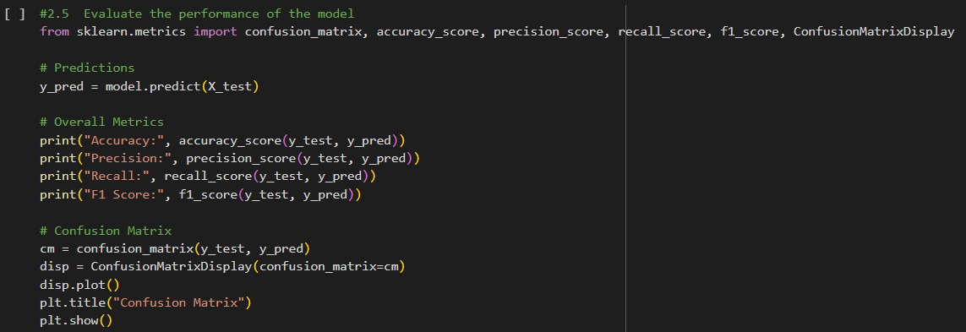
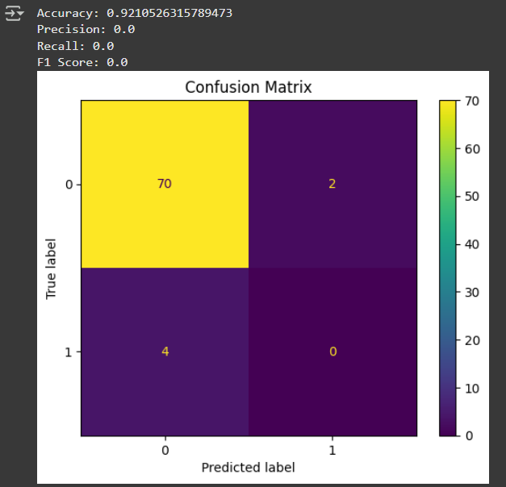
First, we import evaluation functions and display tools from sklearn.metrics. Secondly, we use the trained model to predict outcomes of “is_click” on unseen test data where “X_test” contains the input features and “y_pred” will be an array of predicted labels. We display the confusion matrix along with the following metrics:
accuracy_score: Proportion of total correct predictions.
precision_score: Score of correctly predicted clicks.
recall_score: Proportion of actual clicks that were correctly identified by the model.
f1_score: Harmonic mean of precision and recall and balances both.

2.6 Feature importance and distribution of prediction probabilities
Feature importance is a key tool in model interpretability, helping identify which inputs most affect predictions (Molnar, 2022). In tree models like Random Forest or Decision Tree, it is expressed in terms of how useful a feature is to reduce impurity in decision splits.
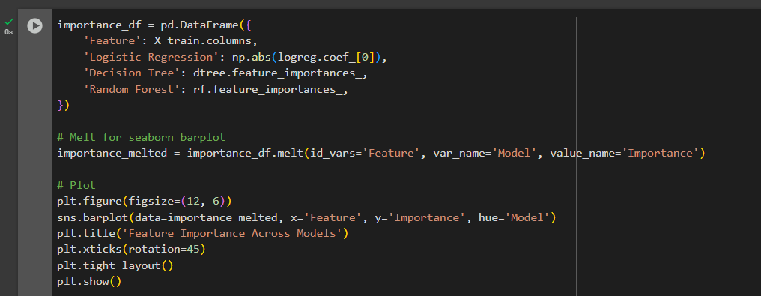
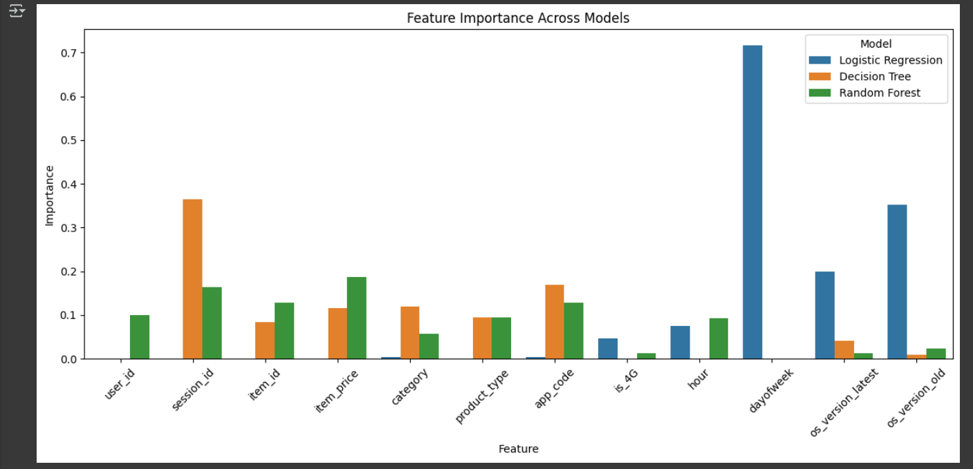
First, we create a DataFrame that holds the “importance” score of each feature for different models.
X_encoded.columns: feature name
logreg.coef_[0]: Coefficients from Logistic Regression.
dtree.feature_importances_: Built-in feature importance from Decision Tree.
rf.feature_importances_: Built-in feature importance from Random Forest.
svm.coef_[0]: Coefficients from Support Vector Machine (SVM).
np.abs(): Used on coefficients since importance is about magnitude, not direction.
“melt()” prepares the DataFrame for visualization by converting it from wide format to long format as libraries like seaborn that expect long format for grouped bar plots.
Lastly, we create a grouped bar chart using seaborn.

2.7 Interpreting the Model
Feature importance analysis indicates a divergence where different models perceive different variables as important. For instance, dayofweek is of significant importance in Logistic Regression but is not in Decision Trees, Random Forest, and SVM, which indicate a linear relation with click predictions. os_version_old is important in Logistic Regression and SVM, while os_version_latest is more important for SVM, indicating some sensitivity of this variable with newer system versions. The hour is particularly important in SVM, implying that the time of interaction plays an important role in click behaviour.

Some important features for SVM include is_4G, category, and app_code, while item_price and product_type are more important features for Random Forest and Decision Trees. These features demonstrate sensitivity to product characteristics. Session_id and item_id show moderate feature importance with Decision Trees and Random Forest, respectively.

The lack of uniformity on feature importance merits choosing the right model depending on the dataset, as each model gives priority to different features. From this perspective, model selection, then, should be made according to those features that bear the most importance to the problem.
In fact, this not only helps in identifying the most predictive features of user behavior but also guides further efforts in feature engineering and dataset balance, in order to increase the classification performance.

Conclusion
The machine learning models built in this project were designed to help predict the click behavior of users within e-commerce sites through session data features. By applying Logistic Regression, Decision Tree, Random Forest, and KNN to this set of data while evaluating them with accuracy, precision, recall, and F1 score, this understanding about machine learning models found that most of them were good at identifying clicked products.
Features like dayofweek and os_version are more important in Logistic Regression, whereas category and app_code dominate in SVM. This knowledge can be applied to further refine the models, potentially leading to more accurate and actionable insights for e-commerce platforms seeking to optimize user engagement and product promotion strategies. Hence, we conclude that product categorization and pricing strategies would be the best ways to optimize click-through rates.

References
Books:
- Géron, A. (2019). Hands-on machine learning with Scikit-Learn and TensorFlow concepts, tools, and techniques to build intelligent systems. 2nd ed. O’Reilly Media, Inc.
- James, G., Witten, D., Hastie, T. and Tibshirani, R. (2013). An Introduction to Statistical Learning : with Applications in R. Springer.
- Loh, W.-Y. (2011). Classification and regression trees. Wiley Interdisciplinary Reviews: Data Mining and Knowledge Discovery, 1(1), pp.14–23. doi:https://doi.org/10.1002/widm.8.
- Manning, C.D., Raghavan, P. and Schütze, H. (2008). Introduction to Information Retrieval. Cambridge: Cambridge University Press.
- Molnar, C. (2019). Interpretable machine learning : a guide for making Black Box Models interpretable. Morisville, North Carolina: Lulu.
- Russel, S. and Norvig, P. (2021). Artificial intelligence: A Modern approach. 4th ed. Prentice Hall.
- Sutton, R.S. and Barto, A. (2018). Reinforcement learning: An introduction. Cambridge, Ma ; London: The Mit Press.
- Tukey, J.W. (1977). Exploratory data analysis. Hoboken, Nj: Pearson.
Journals:
- Loh, W.-Y. (2011). Classification and regression trees. Wiley Interdisciplinary Reviews: Data Mining and Knowledge Discovery, 1(1), pp.14–23. doi:https://doi.org/10.1002/widm.8.
- Sokolova, M. and Lapalme, G. (2009). A systematic analysis of performance measures for classification tasks. Information Processing & Management, 45(4), pp.427–437. doi:https://doi.org/10.1016/j.ipm.2009.03.002.
- Harris, C.R., Millman, K.J., van der Walt, S.J., Gommers, R., Virtanen, P., Cournapeau, D., Wieser, E., Taylor, J., Berg, S., Smith, N.J., Kern, R., Picus, M., Hoyer, S., van Kerkwijk, M.H., Brett, M., Haldane, A., del Río, J.F., Wiebe, M., Peterson, P. and Gérard-Marchant, P. (2020). Array Programming with NumPy. Nature, [online] 585(7825), pp.357–362. doi:https://doi.org/10.1038/s41586-020-2649-2.
- McKinney, W. (2010). Data Structures for Statistical Computing in Python. Proceedings of the 9th Python in Science Conference, 445. doi:https://doi.org/10.25080/majora-92bf1922-00a.

Websites:
- Team, N. (2022). Supervised Learning Types, Algorithms and Applications - Nixus. [online] Nixus. Available at: https://nixustechnologies.com/supervised-machine-learning/.
- IBM (2021). What Is a Decision Tree? [online] Ibm.com. Available at: https://www.ibm.com/think/topics/decision-trees.
- DFNT (2022). Reinforcement Learning in Machine Learning. [online] Nixus. Available at: https://nixustechnologies.com/reinforcement-learning-in-machine-learning/.
- Prabhakaran, S. (2023). Exploratory Data Analysis (EDA) - How to do EDA for Machine Learning Problems using Python - MLPlus. [online] Machine Learning Plus. Available at: https://www.machinelearningplus.com/machine-learning/exploratory-data-analysis-eda/.
- KDnuggets (2017). What is a Support Vector Machine, and Why Would I Use it? - KDnuggets. [online] KDnuggets. Available at: https://www.kdnuggets.com/2017/02/yhat-support-vector-machine.html.
- www.tutorialspoint.com. (n.d.). Machine Learning - Support Vector Machine. [online] Available at: https://www.tutorialspoint.com/machine_learning/machine_learning_support_vector_machine.htm.
- Roy, R. (2019). Best Python libraries for Machine Learning. [online] GeeksforGeeks. Available at: https://www.geeksforgeeks.org/best-python-libraries-for-machine-learning/.
- Brownlee, J. (2020). How to Calculate Feature Importance With Python. [online] Machine Learning Mastery. Available at: https://machinelearningmastery.com/calculate-feature-importance-with-python/.

